Ideation Phase
Empathize & Discover

Date | 31 January 2025
Team ID
Project Name
Maximum Marks | 4 Marks

Empathy Map Canvas:
For the UNESCO World Heritage Treasures dashboard, users such as students, researchers, and travelers want accurate and easy-to-understand information about heritage sites. They think about country-wise distribution and simple comparisons. They feel curious and interested in learning about world culture and history. They say they need clear insights, attractive visuals, and easy filters. They use the dashboard to apply filters, view maps and charts, and analyze data for study, research, or travel planning.

Example:
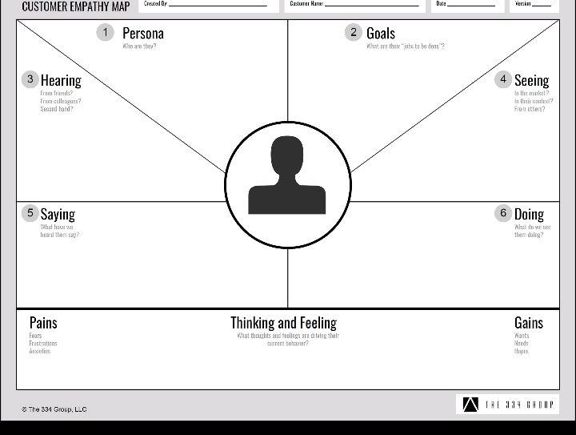

Reference: https://www.mural.co/templates/empathy-map-canvas

Example: Food Ordering & Delivery Application
